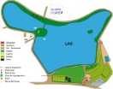 CAMPING DU LAC DE PARISOT, 82160 PARISOT, TEL : 06 17 39 98 26

RESERVATION FORM (please keep a copy)
Name, Firstname  (responsible of stay) | Address
Zip code, city | e-mail
Phone | Portable

Electricity ( 5,00 € / night) yes no

Animal ( vaccination proof to be presented : 2€/3€ / night) yes no
Members of stay :

Name |  | Firstname | Date of Birth

Vehicle (brand, model, colour)……………………………………………………………………………….…
Registration number …………………………………………………………………………………..……….

Stay : | Arrival Date : | Departure Date :
Pitch : | Tent | Caravane | Camper van

Stay amount | Deposit 30% (including 10 € administrative charges) |  | TOTAL
(+ Tourist taxes from 18 years on :0.20 € per night per person to be paid separately on arrival)
(+ Participation on rubbish collection tax : 0.20 € /night/person to be paid separately on arrival)

Please order a wire transfer in Euros (deposit) to following account :
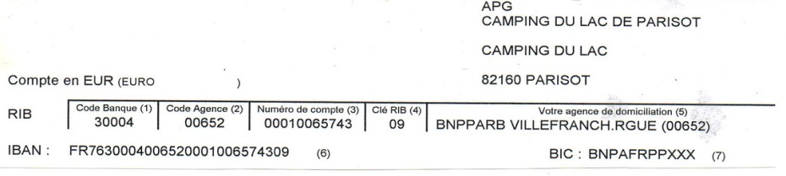

I TOOK NOTE OF GENERAL CONDITIONS AND ACCEPT THEM

At………………………………………..…..Date……………..…………………………………
Signature of responsible :

